600 cols: 800

**clock wise direction form bottom left:**

Choosing source points 0 [189, 500]

Choosing source points 1 [237, 404]

Choosing source points 2 [448, 404]

Choosing source points 3 [537, 495]

**mouse x,y at bottom right corner is [800,600]**

Choosing source points 0 [793, 589]

Choosing source points 0 [191, 497]

Choosing source points 1 [240, 406]

Choosing source points 2 [452, 407]

Choosing source points 3 [535, 490]

Choosing destination points: [185, 385]

Choosing destination points: [533, 385]

Choosing destination points: [533, 501]

Choosing destination points: [185, 501]

600 cols: 800

Choosing source points 0 [166, 587]

Choosing source points 1 [260, 426]

Choosing source points 2 [523, 433]

Choosing source points 3 [647, 586]

[484 x 160 from (157, 429)]

Choosing destination points: [331, 593]

Choosing destination points: [331, 429]

Choosing destination points: [474, 429]

Choosing destination points: [474, 593]

Choosing destination points: [474, 593]

[143 x 164 from (331, 429)]

ppcm width: 0.0377622 ppcm_height: 0.0487805

Perspective Transform Matrix: [-0.3533094995479479, -1.770444793641235, 557.3953069956937;

0.1624698020692046, -3.595786418237763, 1115.419594647802;

0.0002770977906833813, -0.00456378934828412, 1]

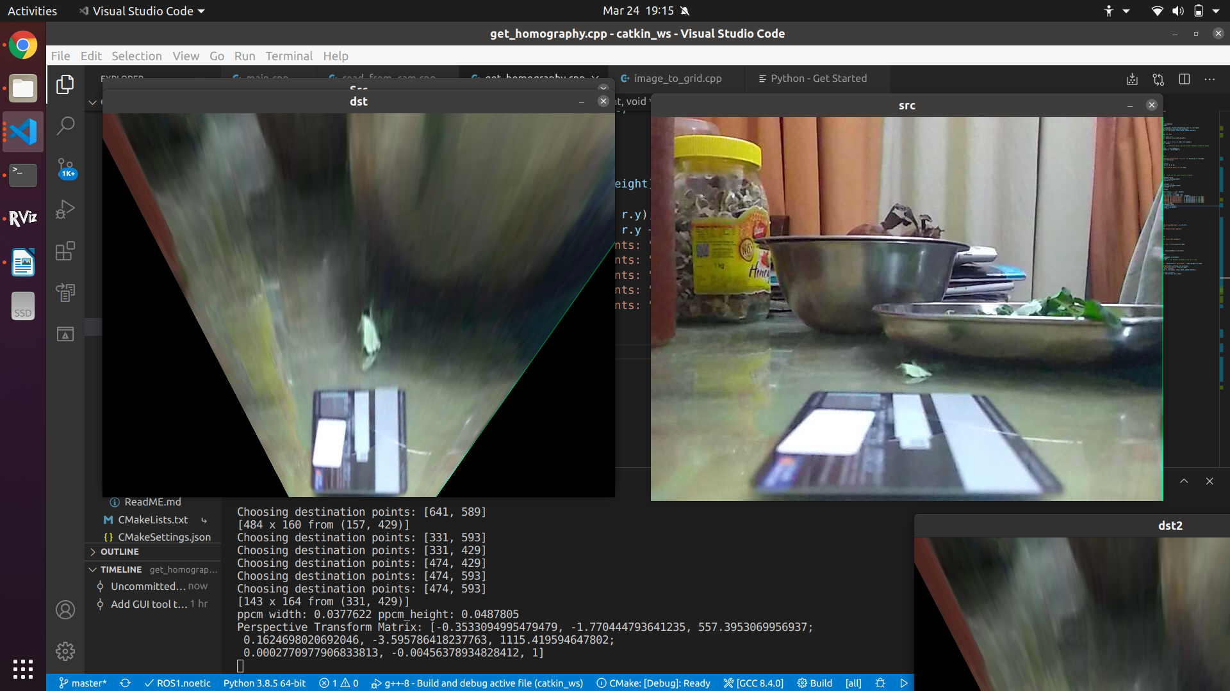

**aswath@aswath-ROG-Zephyrus-G15-GA502IV**:**~/Downloads/vision_opencv/cv_bridge**$ mkdir build

**aswath@aswath-ROG-Zephyrus-G15-GA502IV**:**~/Downloads/vision_opencv/cv_bridge**$ cd build/

**aswath@aswath-ROG-Zephyrus-G15-GA502IV**:**~/Downloads/vision_opencv/cv_bridge/build**$ cmake ..

-- The C compiler identification is GNU 9.3.0

-- The CXX compiler identification is GNU 9.3.0

-- Check for working C compiler: /usr/bin/cc

-- Check for working C compiler: /usr/bin/cc -- works

-- Detecting C compiler ABI info

-- Detecting C compiler ABI info - done

-- Detecting C compile features

-- Detecting C compile features - done

-- Check for working CXX compiler: /usr/bin/c++

-- Check for working CXX compiler: /usr/bin/c++ -- works

-- Detecting CXX compiler ABI info

-- Detecting CXX compiler ABI info - done

-- Detecting CXX compile features

-- Detecting CXX compile features - done

-- Using CATKIN_DEVEL_PREFIX: /home/aswath/Downloads/vision_opencv/cv_bridge/build/devel

-- Using CMAKE_PREFIX_PATH: /home/aswath/slam_ws/devel;/home/aswath/Capstone_Project/catkin_ws/devel;/opt/ros/noetic

-- This workspace overlays: /home/aswath/slam_ws/devel;/home/aswath/Capstone_Project/catkin_ws/devel;/opt/ros/noetic

-- Found PythonInterp: /usr/bin/python3 (found suitable version "3.8.5", minimum required is "3")

-- Using PYTHON_EXECUTABLE: /usr/bin/python3

-- Using Debian Python package layout

-- Found PY_em: /usr/lib/python3/dist-packages/em.py

-- Using empy: /usr/lib/python3/dist-packages/em.py

-- Using CATKIN_ENABLE_TESTING: ON

-- Call enable_testing()

-- Using CATKIN_TEST_RESULTS_DIR: /home/aswath/Downloads/vision_opencv/cv_bridge/build/test_results

-- Forcing gtest/gmock from source, though one was otherwise available.

-- Found gtest sources under &apos;/usr/src/googletest&apos;: gtests will be built

-- Found gmock sources under &apos;/usr/src/googletest&apos;: gmock will be built

-- Found PythonInterp: /usr/bin/python3 (found version "3.8.5")

-- Found Threads: TRUE

-- Using Python nosetests: /usr/bin/nosetests3

-- catkin 0.8.9

-- BUILD_SHARED_LIBS is on

-- Found PythonLibs: /usr/lib/x86_64-linux-gnu/libpython3.8.so (found version "3.8.5")

-- Found Boost: /usr/lib/x86_64-linux-gnu/cmake/Boost-1.71.0/BoostConfig.cmake (found version "1.71.0") found components: python

-- Found CUDA: /usr/local/cuda-11.2 (found suitable exact version "11.2")

-- Found OpenCV: /usr/local (found suitable version "4.4.0", minimum required is "4") found components: opencv_core opencv_imgproc opencv_imgcodecs

-- Found PythonLibs: /usr/lib/x86_64-linux-gnu/libpython3.8.so (found suitable version "3.8.5", minimum required is "3.8")

-- Configuring done

-- Generating done

-- Build files have been written to: /home/aswath/Downloads/vision_opencv/cv_bridge/build

**aswath@aswath-ROG-Zephyrus-G15-GA502IV**:**~/Downloads/vision_opencv/cv_bridge/build**$ cmake ..

-- Using CATKIN_DEVEL_PREFIX: /home/aswath/Downloads/vision_opencv/cv_bridge/build/devel

-- Using CMAKE_PREFIX_PATH: /home/aswath/slam_ws/devel;/home/aswath/Capstone_Project/catkin_ws/devel;/opt/ros/noetic

-- This workspace overlays: /home/aswath/slam_ws/devel;/home/aswath/Capstone_Project/catkin_ws/devel;/opt/ros/noetic

-- Found PythonInterp: /usr/bin/python3 (found suitable version "3.8.5", minimum required is "3")

-- Using PYTHON_EXECUTABLE: /usr/bin/python3

-- Using Debian Python package layout

-- Using empy: /usr/lib/python3/dist-packages/em.py

-- Using CATKIN_ENABLE_TESTING: ON

-- Call enable_testing()

-- Using CATKIN_TEST_RESULTS_DIR: /home/aswath/Downloads/vision_opencv/cv_bridge/build/test_results

-- Forcing gtest/gmock from source, though one was otherwise available.

-- Found gtest sources under &apos;/usr/src/googletest&apos;: gtests will be built

-- Found gmock sources under &apos;/usr/src/googletest&apos;: gmock will be built

-- Found PythonInterp: /usr/bin/python3 (found version "3.8.5")

-- Using Python nosetests: /usr/bin/nosetests3

-- catkin 0.8.9

-- BUILD_SHARED_LIBS is on

-- Found PythonLibs: /usr/lib/x86_64-linux-gnu/libpython3.8.so (found version "3.8.5")

-- Found OpenCV: /usr/local (found suitable version "4.4.0", minimum required is "4.4.0")

-- Found OpenCV: /usr/local (found suitable version "4.4.0", minimum required is "4") found components: opencv_core opencv_imgproc opencv_imgcodecs

-- Found PythonLibs: /usr/lib/x86_64-linux-gnu/libpython3.8.so (found suitable version "3.8.5", minimum required is "3.8")

-- Configuring done

-- Generating done

-- Build files have been written to: /home/aswath/Downloads/vision_opencv/cv_bridge/build

**aswath@aswath-ROG-Zephyrus-G15-GA502IV**:**~/Downloads/vision_opencv/cv_bridge/build**$ make install

**Scanning dependencies of target geometry_msgs_generate_messages_cpp**

[ 0%] Built target geometry_msgs_generate_messages_cpp

**Scanning dependencies of target std_msgs_generate_messages_nodejs**

[ 0%] Built target std_msgs_generate_messages_nodejs

**Scanning dependencies of target std_msgs_generate_messages_cpp**

[ 0%] Built target std_msgs_generate_messages_cpp

**Scanning dependencies of target std_msgs_generate_messages_eus**

[ 0%] Built target std_msgs_generate_messages_eus

**Scanning dependencies of target geometry_msgs_generate_messages_lisp**

[ 0%] Built target geometry_msgs_generate_messages_lisp

**Scanning dependencies of target geometry_msgs_generate_messages_py**

[ 0%] Built target geometry_msgs_generate_messages_py

**Scanning dependencies of target sensor_msgs_generate_messages_nodejs**

[ 0%] Built target sensor_msgs_generate_messages_nodejs

**Scanning dependencies of target sensor_msgs_generate_messages_lisp**

[ 0%] Built target sensor_msgs_generate_messages_lisp

**Scanning dependencies of target geometry_msgs_generate_messages_eus**

[ 0%] Built target geometry_msgs_generate_messages_eus

**Scanning dependencies of target std_msgs_generate_messages_lisp**

[ 0%] Built target std_msgs_generate_messages_lisp

**Scanning dependencies of target std_msgs_generate_messages_py**

[ 0%] Built target std_msgs_generate_messages_py

**Scanning dependencies of target sensor_msgs_generate_messages_cpp**

[ 0%] Built target sensor_msgs_generate_messages_cpp

**Scanning dependencies of target sensor_msgs_generate_messages_eus**

[ 0%] Built target sensor_msgs_generate_messages_eus

**Scanning dependencies of target geometry_msgs_generate_messages_nodejs**

[ 0%] Built target geometry_msgs_generate_messages_nodejs

**Scanning dependencies of target sensor_msgs_generate_messages_py**

[ 0%] Built target sensor_msgs_generate_messages_py

**Scanning dependencies of target cv_bridge**

[ 16%] Building CXX object src/CMakeFiles/cv_bridge.dir/cv_bridge.cpp.o

[ 33%] Building CXX object src/CMakeFiles/cv_bridge.dir/rgb_colors.cpp.o

[ 50%] **Linking CXX shared library ../devel/lib/libcv_bridge.so**

[ 50%] Built target cv_bridge

**Scanning dependencies of target cv_bridge_boost**

[ 66%] Building CXX object src/CMakeFiles/cv_bridge_boost.dir/module.cpp.o

[ 83%] Building CXX object src/CMakeFiles/cv_bridge_boost.dir/module_opencv4.cpp.o

[100%] **Linking CXX shared library ../devel/lib/python3/dist-packages/cv_bridge/boost/cv_bridge_boost.so**

[100%] Built target cv_bridge_boost

Install the project...

-- Install configuration: ""

CMake Error at cmake_install.cmake:46 (file):

file failed to open for writing (Permission denied):

/usr/local/.catkin

make: *** [Makefile:107: install] Error 1

**aswath@aswath-ROG-Zephyrus-G15-GA502IV**:**~/Downloads/vision_opencv/cv_bridge/build**$ sudo make install

[sudo] password for aswath:

[ 0%] Built target geometry_msgs_generate_messages_cpp

[ 0%] Built target std_msgs_generate_messages_nodejs

[ 0%] Built target std_msgs_generate_messages_cpp

[ 0%] Built target std_msgs_generate_messages_eus

[ 0%] Built target geometry_msgs_generate_messages_lisp

[ 0%] Built target geometry_msgs_generate_messages_py

[ 0%] Built target sensor_msgs_generate_messages_nodejs

[ 0%] Built target sensor_msgs_generate_messages_lisp

[ 0%] Built target geometry_msgs_generate_messages_eus

[ 0%] Built target std_msgs_generate_messages_lisp

[ 0%] Built target std_msgs_generate_messages_py

[ 0%] Built target sensor_msgs_generate_messages_cpp

[ 0%] Built target sensor_msgs_generate_messages_eus

[ 0%] Built target geometry_msgs_generate_messages_nodejs

[ 0%] Built target sensor_msgs_generate_messages_py

[ 50%] Built target cv_bridge

[100%] Built target cv_bridge_boost

Install the project...

-- Install configuration: ""

-- Installing: /usr/local/_setup_util.py

-- Installing: /usr/local/env.sh

-- Installing: /usr/local/setup.bash

-- Installing: /usr/local/local_setup.bash

-- Installing: /usr/local/setup.sh

-- Installing: /usr/local/local_setup.sh

-- Installing: /usr/local/setup.zsh

-- Installing: /usr/local/local_setup.zsh

-- Installing: /usr/local/.rosinstall

-- Installing: /usr/local/lib/pkgconfig/cv_bridge.pc

-- Installing: /usr/local/share/cv_bridge/cmake/cv_bridge-extras.cmake

-- Installing: /usr/local/share/cv_bridge/cmake/cv_bridgeConfig.cmake

-- Installing: /usr/local/share/cv_bridge/cmake/cv_bridgeConfig-version.cmake

-- Installing: /usr/local/share/cv_bridge/package.xml

+ cd /home/aswath/Downloads/vision_opencv/cv_bridge

+ mkdir -p /usr/local/lib/python3/dist-packages

+ /usr/bin/env PYTHONPATH=/usr/local/lib/python3/dist-packages:/home/aswath/Downloads/vision_opencv/cv_bridge/build/lib/python3/dist-packages: CATKIN_BINARY_DIR=/home/aswath/Downloads/vision_opencv/cv_bridge/build /usr/bin/python3 /home/aswath/Downloads/vision_opencv/cv_bridge/setup.py egg_info --egg-base /home/aswath/Downloads/vision_opencv/cv_bridge/build build --build-base /home/aswath/Downloads/vision_opencv/cv_bridge/build install --root=/ --install-layout=deb --prefix=/usr/local --install-scripts=/usr/local/bin

running egg_info

creating /home/aswath/Downloads/vision_opencv/cv_bridge/build/cv_bridge.egg-info

writing /home/aswath/Downloads/vision_opencv/cv_bridge/build/cv_bridge.egg-info/PKG-INFO

writing dependency_links to /home/aswath/Downloads/vision_opencv/cv_bridge/build/cv_bridge.egg-info/dependency_links.txt

writing top-level names to /home/aswath/Downloads/vision_opencv/cv_bridge/build/cv_bridge.egg-info/top_level.txt

writing manifest file &apos;/home/aswath/Downloads/vision_opencv/cv_bridge/build/cv_bridge.egg-info/SOURCES.txt&apos;

reading manifest file &apos;/home/aswath/Downloads/vision_opencv/cv_bridge/build/cv_bridge.egg-info/SOURCES.txt&apos;

writing manifest file &apos;/home/aswath/Downloads/vision_opencv/cv_bridge/build/cv_bridge.egg-info/SOURCES.txt&apos;

running build

running build_py

creating /home/aswath/Downloads/vision_opencv/cv_bridge/build/lib/cv_bridge

copying python/cv_bridge/__init__.py -> /home/aswath/Downloads/vision_opencv/cv_bridge/build/lib/cv_bridge

copying python/cv_bridge/core.py -> /home/aswath/Downloads/vision_opencv/cv_bridge/build/lib/cv_bridge

running install

running install_lib

creating /usr/local/lib/python3/dist-packages/cv_bridge

copying /home/aswath/Downloads/vision_opencv/cv_bridge/build/lib/cv_bridge/__init__.py -> /usr/local/lib/python3/dist-packages/cv_bridge

copying /home/aswath/Downloads/vision_opencv/cv_bridge/build/lib/cv_bridge/core.py -> /usr/local/lib/python3/dist-packages/cv_bridge

byte-compiling /usr/local/lib/python3/dist-packages/cv_bridge/__init__.py to __init__.cpython-38.pyc

byte-compiling /usr/local/lib/python3/dist-packages/cv_bridge/core.py to core.cpython-38.pyc

running install_egg_info

Copying /home/aswath/Downloads/vision_opencv/cv_bridge/build/cv_bridge.egg-info to /usr/local/lib/python3/dist-packages/cv_bridge-1.15.0.egg-info

Skipping SOURCES.txt

running install_scripts

-- Installing: /usr/local/include/cv_bridge

-- Installing: /usr/local/include/cv_bridge/cv_bridge.h

-- Installing: /usr/local/include/cv_bridge/rgb_colors.h

-- Installing: /usr/local/lib/python3/dist-packages/cv_bridge/boost/__init__.py

-- Installing: /usr/local/lib/libcv_bridge.so

-- Set runtime path of "/usr/local/lib/libcv_bridge.so" to ""

-- Installing: /usr/local/lib/python3/dist-packages/cv_bridge/boost/cv_bridge_boost.so

-- Set runtime path of "/usr/local/lib/python3/dist-packages/cv_bridge/boost/cv_bridge_boost.so" to ""

**aswath@aswath-ROG-Zephyrus-G15-GA502IV**:**~/Downloads/vision_opencv/cv_bridge/build**